- A wave traveling on a string has a wavelength of 0.10 m and a frequency of 7 Hz. Calculate the speed of the wave.

- A sound wave traveling in water at 1440 m/s has a wavelength of 0.5 m. Determine the frequency of the wave.

- A storm has created a series of waves across lake Erie traveling at 4.5 m/s with a frequency of .65 Hz. Find the wavelength of this wave.

- A water wave is moving across the surface of a lake in an easterly direction. The wave has a wavelength of 2 m and a frequency of 2.5 cycles/s. Draw a diagram of this situation, looking down from above the lake, showing 5 wavefronts. Label the wavelength and show the direction of propagation by using a ray.

- A sound wave is moving through air. The wave has a wavelength of 0.65 m and a frequency of 512 Hz. Draw a diagram of this situation, showing 5 wavefronts moving due north. Label the wavelength and show the direction of propagation by using a ray.

- A water wave moving due east across a lake traveling at 5 m/s has a frequency of 0.40Hz.

a. Calculate the wavelength.

b. Calculate the distance from one crest to the next trough.

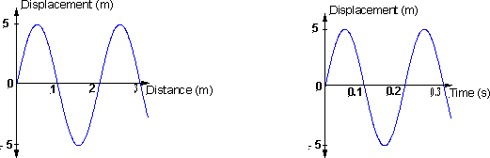
- The following two graphs represent data from the same wave traveling due west through a particular medium. From the graphs determine: (a) the wavelength; (b) the amplitude; (c) the period; (d) the frequency and (e) the velocity of the wave.
a.

b.

c.

d.

e.

- Write the wave equation, f(x,t) = Asin(t + x), for the waveform in the previous question using the appropriate substitutions for  and .

- A rope is stretched between two vertical supports. The points where it’s attached are fixed. The length of the rope is 2 meters and the mass of the rope is 0.8 kg. If the speed of a transverse wave is 12 m/s:
a. what is the tension in the rope?

b. what is the frequency if the wavelength is the same as the distance between the two supports?

